UNITED STATES
SECURITIES AND EXCHANGE COMMISSION
Washington, D.C. 20549
___________________________________

FORM 8-K
_________________________________

CURRENT REPORT

Pursuant to Section 13 or 15(d) of the Securities Exchange Act of 1934

date of Report (Date of earliest event reported): August 1, 2019
___________________________________

MRC Global inc.
(Exact name of registrant as specified in its charter)
___________________________________

 |  |  | Identification Number)
Delaware  (State or other jurisdiction of incorporation) |  | 001-35479  (Commission  File Number) | 20-5956993  (I.R.S. Employer  Identification Number)
Fulbright Tower, 1301 McKinney Street, Suite 2300
Houston, Texas 77010
(Address of Principal Executive Offices)

Registrant’s telephone number, including area code: (877) 294-7574

Check the appropriate box below if the Form 8-K filing is intended to simultaneously satisfy the filing obligation of the registrant under any of the following provisions (see General Instruction A.2. below):

[ ] Written communications pursuant to Rule 425 under the Securities Act (17 CFR 230.425)

[ ] Soliciting material pursuant to Rule 14a-12 under the Exchange Act (17 CFR 240.14a-12)

[ ] Pre-commencement communications pursuant to Rule 14d-2(b) under the Exchange Act (17 CFR 240.14d-2(b))

[ ] Pre-commencement communications pursuant to Rule 13e-4(c) under the Exchange Act (17 CFR 240.13e-4(c))

Securities registered pursuant to Section 12(b) of the Act:
Title of each class | Trading symbol(s) | Name of each exchange on which registered
Common Stock, par value $0.01 | MRC | New York Stock Exchange

Indicate by check mark whether the registrant is an emerging growth company as defined in Rule 405 of the Securities Act of 1933 (§230.405 of this chapter) or Rule 12b-2 of the Securities Exchange Act of 1934 (§240.12b-2 of this chapter).

Emerging growth company ☐

If an emerging growth company, indicate by check mark if the registrant has elected not to use the extended transition period for complying with any new or revised financial accounting standards provided pursuant to Section 13(a) of the Exchange Act. ☐

Item 2.02 Results of Operations and Financial Condition
On August 1, 2019, MRC Global Inc. (“MRC Global” or the “Company”) issued a press release announcing its financial results for the three and six months ended June 30, 2019. A copy of the press release is furnished as Exhibit 99.1 to this Form 8-K and is incorporated herein by reference.
In accordance with General Instruction B.2 of Form 8-K, the information in Item 2.02 of this Current Report on Form 8-K, including Exhibit 99.1, shall not be deemed to be "filed" for purposes of Section 18 of the Securities Exchange Act of 1934, as amended (the "Exchange Act"), or otherwise subject to the liability of that section, and shall not be incorporated by reference into any registration statement or other document filed under the Securities Act of 1933, as amended, or the Exchange Act, except as shall be expressly set forth by specific reference in such filing.
Item 5.02 Departure of Directors or Certain Officers; Election of Directors; Appointment of Certain Officers; Compensatory Arrangements of Certain Officers
James E. Braun, the Company’s Executive Vice President and Chief Financial Officer, notified the Company on July 30, 2019 that he intends to retire on March 1, 2020. The Company has entered into a First Amendment to Employment Agreement, dated as of July 30, 2019 (the “Amendment”), with Mr. Braun to extend the term of Mr. Braun’s employment until March 1, 2020. Pursuant to the Amendment, if Mr. Braun serves through the extended date of his term, the Company terminates Mr. Braun’s employment other than for Cause, death or Disability prior to this date, or if Mr. Braun leaves for Good Reason prior to this date, Mr. Braun will be deemed to have satisfied any requirement that the Participant’s age plus years of service equal at least 80 for the purposes of equity awards that the Company granted to him under the Company’s 2011 Omnibus Incentive Plan, as amended, prior to his departure and will be considered “retired” when he leaves the Company’s employ; and, after he leaves the Company, Mr. Braun will continue to vest in any Restricted Stock Unit awards that the Company granted to him pursuant to the retirement provisions of the applicable award agreements as modified by the Amendment and will be eligible to receive shares based on the performance formula set forth under any Performance Share Unit award that the Company granted to him prior to his departure, prorated for the length of his service during any applicable performance period. To receive the retirement benefit of continued vesting, Mr. Braun must meet the Company’s Equity Ownership Guidelines measured as of March 1, 2020 (if his employment is not terminated prior to that date) and continue to adhere to the restrictive covenants in each award agreement, including those that require him to maintain the confidentiality of non-public, confidential or proprietary information of the Company, to refrain from competition with the Company and to refrain from the solicitation of employment of Company employees, in each case, until the award is fully vested during retirement.

Item 7.01 Regulation FD Disclosure.

Guidance Update

MRC Global expects the following results with respect to the operations and performance of the Company for the 2019 fiscal year:

- The Company expects 2019 revenue to be between $3,850 million and $4,050 million.

- Sequentially, the Company expects third quarter 2019 revenue to be up approximately 2%-4% from the second quarter of 2019.

- Given MRC Global’s current mix of products, the Company expects a gross profit percentage between 17.7% and 18.1% and an Adjusted Gross Profit percentage between 19.4% and 19.6% for 2019. Adjusted Gross Profit percentage is a non-GAAP measure that is not necessarily better than gross profit percentage. The Company defines Adjusted Gross Profit as sales, less cost of sales, plus depreciation and amortization, plus amortization of intangibles, and plus or minus the impact of its last-in, first-out (“LIFO”) inventory costing methodology. The Company presents Adjusted Gross Profit because the Company believes it is a useful indicator of the Company’s operating performance without regard to items, such as amortization of intangibles, that can vary substantially from company to company depending upon the nature and extent of acquisitions of which they have been involved. Similarly, the impact of the LIFO inventory costing method can cause results to vary substantially from company to company depending upon whether they elect to utilize LIFO and depending upon which method they may elect. The Company uses Adjusted Gross Profit as a key performance indicator in managing its business. The Company believes that gross profit is the financial measure calculated and presented in accordance with U.S. generally accepted accounting principles that is most directly comparable to Adjusted Gross Profit.

The following table reconciles gross profit and gross profit percentage, GAAP measures, to Adjusted Gross Profit and Adjusted Gross Profit percentage, non-GAAP measures (in millions):

 | Expected for the Year Ended 2019 |  | Percentage of Expected Revenue*
Gross profit | $ | 709 | 17.9%
Depreciation and amortization |  | 22 | 0.6%
Amortization of intangibles |  | 42 | 1.1%
Decrease in LIFO reserve |  | (3) | (0.1%)
Adjusted Gross Profit | $ | 770 | 19.5%

* Percentages are based on the midpoint of revenue guidance provided above.

- The Company expects the impact of LIFO to be between $10 million of income and $10 million of expense in 2019.

- The Company expects selling, general and administrative expense to be between $540 million and $550 million in 2019.

- The Company expects equity-based compensation expense to be $15 million in 2019.

- The Company expects to generate between $180 million and $220 million of cash from operations in 2019.

- The Company expects to have an effective tax rate of 25% for the full year of 2019.

- The Company expects its total capital expenditures for 2019 to be between $15 million and $20 million.

- The Company expects diluted income per common share to be between $0.75 and $0.95.

- The Company expects to have net income (before preferred stock dividend) between $85 million and $105 million and Adjusted EBITDA between $230 million and $250 million in 2019. Adjusted EBITDA is a non-GAAP measure that is not necessarily better than net income. The Company defines Adjusted EBITDA as net income plus interest, income taxes, depreciation and amortization, amortization of intangibles and certain other expenses, including non-cash expenses (such as equity-based compensation, severance and restructuring, changes in the fair value of derivative instruments and asset impairments, including inventory) and plus or minus the impact of our LIFO inventory costing methodology. The Company presents Adjusted EBITDA because the Company believes it provides investors a helpful measure for comparing our operating performance with the performance of other companies that have different financing and capital structures or tax rates. We believe that net income is the financial measure calculated and presented in accordance with U.S. generally accepted accounting principles that is most directly comparable to Adjusted EBITDA.

The following table reconciles net income, a GAAP measure, with Adjusted EBITDA, a non-GAAP measure, based on the mid-point of the guidance (in millions):

 | Expected for the Year Ended 2019
Net income | $ | 95
Income tax expense |  | 30
Interest expense |  | 39
Depreciation and amortization |  | 22
Amortization of intangibles |  | 42
Decrease in LIFO reserve |  | (3)
Equity-based compensation expense |  | 15
Adjusted EBITDA | $ | 240

The current 2019 outlook and expectations outlined above do not reflect the impact of any restructuring charges for actions currently being considered.

The above information, as well as information contained in Exhibit 99.1 referenced under Item 9.01 below, contain forward-looking statements within the meaning of Section 27A of the Securities Act and Section 21E of the Exchange Act. Words such as “will,” “expect,” “expects,” “expected,” “believes,” “looking forward,” “guidance” and similar expressions are intended to identify forward-looking statements.

Statements about the company’s business, including its strategy, its industry, the company’s future profitability, the company’s guidance on its sales, Adjusted EBITDA, gross profit, gross profit percentage, Adjusted Gross Profit and Adjusted Gross Profit percentage, tax rate, capital expenditures and cash from operations, growth in the company’s various markets and the company’s expectations, beliefs, plans, strategies, objectives, prospects and assumptions are not guarantees of future performance. These statements are based on management’s expectations that involve a number of business risks and uncertainties, any of which could cause actual results to differ materially from those expressed in or implied by the forward-looking statements. These statements involve known and unknown risks, uncertainties and other factors, most of which are difficult to predict and many of which are beyond our control, including the factors described in the company’s SEC filings that may cause our actual results and performance to be materially different from any future results or performance expressed or implied by these forward-looking statements.

With respect to net income (before preferred stock dividend) and diluted earnings per share, these risks include actual share count, LIFO expense and the other component expectations listed above meeting the Company’s expectations for each component. These risks and uncertainties also include (among others) decreases in oil and natural gas prices; decreases in oil and natural gas industry expenditure levels, which may result from decreased oil and natural gas prices or other factors; increased usage of alternative fuels, which may negatively affect oil and natural gas industry expenditure levels; U.S. and international general economic conditions; the company’s ability to compete successfully with other companies in MRC Global’s industry; the risk that manufacturers of the products the company distributes will sell a substantial amount of goods directly to end users in the industry sectors the company serves; unexpected supply shortages; cost increases by the company’s suppliers; the company’s lack of long-term contracts with most of its suppliers; suppliers’ price reductions of products that the company sells, which could cause the value of the company’s inventory to decline; decreases in steel prices, which could significantly lower MRC Global’s profit; increases in steel prices, which the company may be unable to pass along to its customers which could significantly lower its profit; the company’s lack of long-term contracts with many of its customers and the company’s lack of contracts with customers that require minimum purchase volumes; changes in the company’s customer and product mix; risks related to the company’s customers’ creditworthiness; the success of the company’s acquisition strategies; the potential adverse effects associated with integrating acquisitions into the company’s business and whether these acquisitions will yield their intended benefits; the company’s significant indebtedness; the dependence on the company’s subsidiaries for cash to meet its debt obligations; changes in the company’s credit profile; a decline in demand for certain of the products the company distributes if import restrictions on these products are lifted; environmental, health and safety laws and regulations and the interpretation or implementation thereof; the sufficiency of the company’s insurance policies to cover losses, including liabilities arising from litigation; product liability claims against the company; pending or future asbestos-related claims against the company; the potential loss of key personnel; interruption in the proper functioning of the company’s information systems and the occurrence of cyber security incidents; loss of third-party transportation providers; potential inability to obtain necessary capital; risks related to adverse weather events or natural disasters; impairment of our goodwill or other intangible assets; adverse changes in political or economic conditions in the countries in which the company operates; exposure to U.S. and international laws and regulations, including the U.S. Foreign Corrupt Practices Act and the U.K. Bribery Act and other economic sanction programs; risks associated with international stability and geopolitical developments; risks relating to ongoing evaluations of internal controls required by Section 404 of the Sarbanes-Oxley Act; risks related to the Company’s intention not to pay dividends; and risks arising from compliance with and changes in laws and regulations in the countries in which we operate, including (among others) changes in tax law, tax rates and interpretation in tax laws, changes in trade and other treaties that lead to differing tariffs and trade rules, the expansion of currency exchange controls, export controls or additional restrictions on doing business in countries subject to sanctions in which we operate or intend to operate. In addition, the Company’s intention to continue to repurchase shares of the Company’s common stock is also subject to the trading price of the stock being at prices that the Company believes are favorable to stockholders and to the Company’s debt and liquidity levels being at levels the Company deems sufficient to repurchase shares.

For a discussion of key risk factors, please see the risk factors disclosed in the company’s SEC filings, which are available on the SEC’s website at www.sec.gov and on the company’s website, www.mrcglobal.com. Our filings and other important information are also available on the Investor Relations page of our website at www.mrcglobal.com.

Undue reliance should not be placed on the company’s forward-looking statements. Although forward-looking statements reflect the company’s good faith beliefs, reliance should not be placed on forward-looking statements because they involve known and unknown risks, uncertainties and other factors, which may cause the company’s actual results, performance or achievements or future events to differ materially from anticipated future results, performance or achievements or future events expressed or implied by such forward-looking statements. The company undertakes no obligation to publicly update or revise any forward-looking statement, whether as a result of new information, future events, changed circumstances or otherwise, except to the extent required by law.

The information referenced under Item 7.01 (including Exhibit 99.1 referenced under Item 9.01 below) of this Current Report on Form 8-K is being “furnished” under “Item 7.01. Regulation FD Disclosure” and, as such, shall not be deemed to be “filed” for the purposes of Section 18 of the Securities Exchange Act of 1934, as amended, or otherwise subject to the liabilities of that section. The information set forth in this Current Report on Form 8-K (including Exhibit 99.1 referenced under Item 9.01 below) shall not be incorporated by reference into any registration statement, report or other document filed by MRC Global pursuant to the Securities Act of 1933, as amended, except as shall be expressly set forth by specific reference in such filing.

Earnings Presentation

On August 1, 2019, MRC Global Inc. announced its financial results for the three and six months ended June 30, 2019. In conjunction with this release, the Company issued a presentation summarizing the highlights of the financial results (the “Earnings Presentation”). A copy of the Earnings Presentation is furnished as Exhibit 99.2 to this Form 8-K and is incorporated herein by reference.
The information contained in the Earnings Presentation is summary information that should be considered in the context of MRC Global’s filings with the Securities and Exchange Commission and other public announcements that MRC Global may make by press release or otherwise from time to time. The Earnings Presentation speaks as of the date of this Current Report on Form 8-K. While MRC Global may elect to update the Earnings Presentation in the future or reflect events and circumstances occurring or existing after the date of this Current Report on Form 8-K, MRC Global specifically disclaims any obligation to do so. The Earnings Presentation will also be posted in the Investor Relations section of MRC Global’s website, http://www.mrcglobal.com.

The information referenced under Item 7.01 (including Exhibit 99.2 referenced under Item 9.01 below) of this Current Report on Form 8-K is being “furnished” under “Item 7.01. Regulation FD Disclosure” and, as such, shall not be deemed to be “filed” for the purposes of Section 18 of the Securities Exchange Act of 1934, as amended, or otherwise subject to the liabilities of that section. The information set forth in this Current Report on Form 8-K (including Exhibit 99.2 referenced under Item 9.01 below) shall not be incorporated by reference into any registration statement, report or other document filed by MRC Global pursuant to the Securities Act of 1933, as amended, except as shall be expressly set forth by specific reference in such filing.

Item 9.01 Financial Statements and Exhibits.

(d) |  | Exhibits.
10.1 |  | First Amendment to Employment Agreement, dated as of July 30, 2019, between MRC Global Inc. and James E. Braun.
99.1 |  | Press release of MRC Global Inc. dated August 1, 2019
99.2 |  | Earnings Presentation of MRC Global Inc. dated August 1, 2019

INDEX TO EXHIBITS

re
Exhibit No. |  | Description
10.1 |  | First Amendment to Employment Agreement, dated as of July 30, 2019, between MRC Global Inc. and James E. Braun.
99.1 |  | Press release dated August 1, 2019
99.2 |  | Earnings Presentation dated August 1, 2019

SIGNATURES
Pursuant to the requirements of the Securities Exchange Act of 1934, the registrant has duly caused this report to be signed on its behalf by the undersigned hereunto duly authorized.
Date: August 1, 2019
 | MRC GLOBAL Inc.
 | By: | /s/ James E. Braun
 | James E. Braun
 | Executive Vice President and Chief Financial Officer

THIS FIRST AMENDMENT TO EMPLOYMENT AGREEMENT (this “Amendment”) is adopted, executed and agreed to as of this 30th day of July, 2019 (the “Effective Date”), between MRC Global Inc., a Delaware corporation (“Company”), and James E. Braun (“Executive”), which are referred to as the parties to this Amendment.
WHEREAS, the parties previously entered into that certain Employment Agreement dated February 18, 2014 (including any and all exhibits and other attachments thereto, the “Employment Agreement”); and
WHEREAS, the parties desire and deem it to be in their respective best interests to amend the Employment Agreement as set forth in this Amendment.
NOW, THEREFORE, in consideration of the premises and the mutual covenants and agreements contained in this Amendment, and other valid consideration, the sufficiency of which the parties acknowledge, the parties agree to amend the Employment Agreement as follows:
ARTICLE I
AMENDMENTS TO EMPLOYMENT AGREEMENT
The Employment Agreement is amended by:
(1) Deleting 1.1 in its entirety and substituting in its place the following:
“Term. The Company agrees to employ the Executive, and the Executive agrees to be employed by the Company, in each case, pursuant to this Agreement, for a period commencing on the Effective Date and ending on the earlier of:
(i) March 1, 2020 (the “Target Date”) and
(ii) the termination of the Executive’s employment in accordance with Section 3 (the “Term”).
(2) Adding a new Section 2.7 that reads as follows:
“Retirement. If Executive remains employed by the Company on or after the Target Date, the Company terminates Executive’s employment other than for Cause, death or Disability prior to the Target Date or the Executive terminates employment for Good Reason prior to the Target Date, Executive shall be deemed “Retired” and to have satisfied any requirement that the Participant’s age plus years of service equal to at least 80 for the purposes of any equity award agreement granted pursuant to the Company’s 2011 Omnibus Incentive Plan, as amended, including (without limitation) any Restricted Stock Agreement, Restricted Stock Unit Award Agreement, Performance Share Unit Award Agreement or Stock Option Agreement and Executive shall be entitled to continued vesting pursuant to the retirement provisions of each such agreement
and any requirement under the award agreement that Executive must remain employed with the Company for any period of time prior to such Retirement for the award to vest will be waived; provided, that in the case of any Performance Share Unit Award Agreement the amount payable under the award shall be prorated as provided in the provision concerning "Termination under an Employment Agreement" set forth in Section 5.4 of the applicable Performance Share Unit Award Agreement (notwithstanding the provisions in the "Retirement" provision of the award set forth in Section 5.3) and in the case of any Restricted Stock Unit Award Agreement the amount payable under the award shall be payable within 30 days following the date the award becomes vested. Notwithstanding the foregoing in this Section 2.7, Executive shall only be entitled to the retirement treatment that this Section 2.7 provides if Executive meets the Company’s Equity Ownership Guidelines measured as of the Target Date; provided that this requirement only applies if Executive’s employment is not otherwise terminated prior to the Target Date.”
ARTICLE II
MISCELLANEOUS
This Amendment is incorporated into and is a part of the Employment Agreement. Except to the extent modified by this Amendment, the Employment Agreement shall continue in full force and effect in accordance with its provisions.
This Amendment shall be construed and enforced in accordance with, and the rights and obligations of the parties shall be governed by, the laws of the State of Texas, without giving effect to the conflicts of law principles thereof.
This Amendment may be executed in any number of counterparts, each of which shall be deemed an original, but all such counterparts shall together constitute one and the same instrument. This Amendment may be delivered through the means of email delivery of a portable document format (.pdf) file or similar transmission of the signed Amendment.
IN WITNESS WHEREOF, each of the undersigned has executed this Amendment as of the Effective Date.
MRC GLOBAL Inc.
By:
Andrew R. Lane
President & CEO
James E. Braun

MRC Global Announces Second Quarter 2019 Results
CFO Announces Retirement Plans

Sales of $984 million
Net income attributable to common stockholders of $18 million
Diluted earnings per common share of $0.21
Adjusted EBITDA of $60 million

Houston, TX – August 1, 2019 – MRC Global Inc. (NYSE: MRC), the largest global distributor, based on sales, of pipe, valves and fittings and related products and services to the energy industry, today announced second quarter 2019 results.

The company’s sales were $984 million for the second quarter of 2019, which was 1% higher than the first quarter of 2019 and 9% lower than the second quarter of 2018. The sequential improvement was driven by an increase in the midstream sector. As compared to the second quarter of 2018, the decrease was across all segments and end-markets.

Net income attributable to common stockholders for the second quarter of 2019 was $18 million, or $0.21 per diluted share, as compared to $16 million, or $0.17 per diluted share in the second quarter of 2018.

Andrew R. Lane, MRC Global’s president and chief executive officer stated, “Customer spending levels did not increase in the second quarter as we expected, and, in fact, they fell, particularly in the latter part of the quarter, which caused our second quarter results to come in below our expectations and led us to lower our guidance for the year. As we have consistently done in periods of reduced customer activity like this, we will aggressively manage operating costs, and focus on free cash flow generation and debt reduction. As such, we now expect to generate cash from operations of approximately $200 million in 2019. Our strong customer contract positions with recent significant wins and renewals as well as the launch of MRCGOTM, an end-to-end digital supply chain solution, demonstrate our commitment to maintaining our leading position in the PVF distribution industry.”

MRC Global’s second quarter 2019 gross profit was $174 million, or 17.7% of sales, as compared to gross profit of $177 million, or 16.4% of sales, in the second quarter of 2018. Gross profit for the second quarter of 2019 and 2018 reflects income of $1 million and expense of $15 million, respectively, in cost of sales relating to the use of the last-in, first out (LIFO) method of inventory cost accounting. The improvement in gross profit percent was attributable primarily to the lower LIFO expense. Gross profit percent was negatively impacted by lower line pipe pricing and general pricing pressures experienced in the quarter.

Selling, general and administrative expenses were $133 million, or 13.5% of sales, for the second quarter of 2019 compared to $136 million, or 12.6% of sales, for the same period of 2018. Lower personnel costs were primarily responsible for the year over year decline.

Adjusted EBITDA was $60 million in the second quarter of 2019 compared to $78 million for the same period in 2018. Please refer to the reconciliation of non-GAAP measures (adjusted gross profit and adjusted EBITDA) to GAAP measures (gross profit and net income) in this release.

Sales by Segment

U.S. sales in the second quarter of 2019 were $806 million, down $72 million, or 8%, from the same quarter in 2018. Midstream declined $49 million, or 11% and downstream declined by $22 million, or 9%, both primarily due to non-recurring project work.

Canadian sales in the second quarter of 2019 were $58 million, down $22 million, or 28%, from the same quarter in 2018 driven by the upstream sector, which continues to be negatively impacted by low Canadian oil prices and government-imposed production limits. A weaker Canadian dollar relative to the U.S. dollar unfavorably impacted sales by $2 million.

International sales in the second quarter of 2019 were $120 million, down $4 million, or 3%, from the same period in 2018 driven by the conclusion of a major project in Kazakhstan, as well as, the impact of weaker foreign currencies relative to the U.S. dollar, which unfavorably impacted sales by $7 million. Excluding the impact of the project and weaker foreign currencies, sales increased $12 million due to improving market conditions, particularly in Norway and the United Kingdom.

Sales by Sector

Upstream sales in the second quarter of 2019 decreased 7% over the second quarter of 2018 to $284 million, or 29% of total sales. The decrease in upstream sales was driven primarily by the Canadian segment.

Midstream sales in the second quarter of 2019 were $421 million, or 43% of total sales, down $51 million or, 11%, from the second quarter of 2018. Sales to gas utility customers were up by 10%, while sales to transmission and gathering customers were down 30% over the same quarter in 2018 due to non-recurring projects.

Downstream sales in the second quarter of 2019 were $279 million, or 28% of total sales, down $24 million or 8% from the second quarter of 2018 due primarily to non-recurring project work in the U.S.

Balance Sheet

Cash balances were $35 million at June 30, 2019. Debt, net of cash, was $703 million and excess availability under our asset-based lending facility was $385 million as of June 30, 2019. Cash provided by operations was $48 million in the second quarter of 2019 resulting in $8 million of cash provided by operations for the first half of 2019. MRC Global’s liquidity position of $420 million is sufficient to support the business and capital needs of the Company.

Share Repurchase Program Update

In October 2018, the board of directors authorized a share repurchase program for common stock of up to $150 million. As previously reported, during the second quarter of 2019, the Company purchased $25 million of its common stock at an average price of $18.24 per share. There is $25 million remaining available under the current authorization.

The shares may be repurchased at management’s discretion in the open market. Depending on market conditions and other factors, these repurchases may be commenced or suspended from time to time without prior notice. The current program is scheduled to expire on December 31, 2019.

Since 2015, the Company has repurchased $350 million or 22.5 million shares at an average price of $15.58 per share. The outstanding share count as of June 30, 2019 was 83.1 million shares.

Updated 2019 Annual Guidance

The Company is updating its 2019 annual guidance to reflect a reduction in customer spending levels in the second quarter and lower expectations for the remainder of the year. The Company expects sales in the third quarter to be improved over the second quarter by 2% to 4% and expects modest growth in the second half of the year as compared to the first half of the year.

2019 Annual Guidance
 | Low |  | High
Revenue | $3,850 million |  | $4,050 million
Net income (before preferred stock dividends) | $85 million |  | $105 million
Diluted income per common share | $0.75 |  | $0.95
Adjusted EBITDA | $230 million |  | $250 million
Cash flow from operations | $180 million |  | $220 million

- Current 2019 annual guidance does not reflect the impact of any restructuring charges for actions currently being considered
- Please refer to the reconciliation of Net income to Adjusted EBITDA in this release.

CFO Retirement Plans

James E. Braun, Executive Vice President and Chief Financial Officer, age 60, has advised the board of directors of his intention to retire from MRC Global Inc. on March 1, 2020. James has served as CFO since joining the Company in 2011. The Company is conducting a search for a new CFO.

Mr. Lane added, “I want to thank Jim for all his contributions to MRC Global over the past 8 years. He has been a valued and respected member of my management team and I wish him all the best in retirement.”

Conference Call

The Company will hold a conference call to discuss its second quarter 2019 results at 10:00 a.m. Eastern Time (9:00 a.m. Central Time) on August 2, 2019. To participate in the call, please dial 412-902-0003 and ask for the MRC Global conference call at least 10 minutes prior to the start time. To access the conference call, live over the Internet, please log onto the web at www.mrcglobal.com and go to the “Investor Relations” page of the company’s website at least fifteen minutes early to register, download and install any necessary audio software. For those who cannot listen to the live call, a replay will be available through August 16, 2019 and can be accessed by dialing 201-612-7415 and using pass code 13691569#. Also, an archive of the webcast will be available shortly after the call at www.mrcglobal.com for 90 days.

About MRC Global Inc.

MRC Global is the largest distributor of pipe, valves and fittings (PVF) and related infrastructure products and services to the energy industry, based on sales. Through approximately 300 service locations worldwide, over 3,500 employees and with nearly 100 years of history, MRC Global provides innovative supply chain solutions and technical product expertise to customers globally across diversified end-markets including the upstream, midstream (including gas utilities) and downstream (including industrials). MRC Global manages a complex network of over 200,000 SKUs and 11,000 suppliers simplifying the supply chain for its over 15,000 customers. With a focus on technical products, value-added services, a global network of valve and engineering centers and an unmatched quality assurance program, MRC Global is the trusted PVF expert. Find out more at www.mrcglobal.com.

This news release contains forward-looking statements within the meaning of Section 27A of the Securities Act and Section 21E of the Exchange Act. Words such as “expect,” “expected,” “intend,” “believes,” “well positioned,” “strong position,” “looking forward,” “guidance,” “plans” and similar expressions are intended to identify forward-looking statements.
Statements about the company’s business, including its strategy, its industry, the company’s future profitability, the company’s guidance on its sales, adjusted EBITDA, tax rate, capital expenditures and cash flow, growth in the company’s various markets and the company’s expectations, beliefs, plans, strategies, objectives, prospects and assumptions are not guarantees of future performance. These statements are based on management’s expectations that involve a number of business risks and uncertainties, any of which could cause actual results to differ materially from those expressed in or implied by the forward-looking statements. These statements involve known and unknown risks, uncertainties and other factors, most of which are difficult to predict and many of which are beyond our control, including the factors described in the company’s SEC filings that may cause our actual results and performance to be materially different from any future results or performance expressed or implied by these forward-looking statements.
These risks and uncertainties include (among others) decreases in oil and natural gas prices; decreases in oil and natural gas industry expenditure levels, which may result from decreased oil and natural gas prices or other factors; increased usage of alternative fuels, which may negatively affect oil and natural gas industry expenditure levels; U.S. and international general economic conditions; the company’s ability to compete successfully with other companies in MRC Global’s industry; the risk that manufacturers of the products the company distributes will sell a substantial amount of goods directly to end users in the industry sectors the company serves; unexpected supply shortages; cost increases by the company’s suppliers; the company’s lack of long-term contracts with most of its suppliers; suppliers’ price reductions of products that the company sells, which could cause the value of the company’s inventory to decline; decreases in steel prices, which could significantly lower MRC Global’s profit; increases in steel prices, which the company may be unable to pass along to its customers which could significantly lower its profit; the company’s lack of long-term contracts with many of its customers and the company’s lack of contracts with customers that require minimum purchase volumes; changes in the company’s customer and product mix; risks related to the company’s customers’ creditworthiness; the success of the company’s acquisition strategies; the potential adverse effects associated with integrating acquisitions into the company’s business and whether these acquisitions will yield their intended benefits; the company’s significant indebtedness; the dependence on the company’s subsidiaries for cash to meet its obligations; changes in the company’s credit profile; a decline in demand for certain of the products the company distributes if import restrictions on these products are lifted; environmental, health and safety laws and regulations and the interpretation or implementation thereof; the sufficiency of the company’s insurance policies to cover losses, including liabilities arising from litigation; product liability claims against the company; pending or future asbestos-related claims against the company; the potential loss of key personnel; interruption in the proper functioning of the company’s information systems and the occurrence of cyber security incidents; loss of third-party transportation providers; potential inability to obtain necessary capital; risks related to adverse weather events or natural disasters; impairment of our goodwill or other intangible assets; adverse changes in political or economic conditions in the countries in which the company operates; exposure to U.S. and international laws and regulations, including the U.S. Foreign Corrupt Practices Act and the U.K. Bribery Act and other economic sanction programs; risks associated with international stability and geopolitical developments, risks relating to ongoing evaluations of internal controls required by Section 404 of the Sarbanes-Oxley Act; risks related to the company’s intention not to pay dividends; and risks arising from compliance with and changes in law in the countries in which we operate, including (among others) changes in tax law, tax rates and interpretation in tax laws. In addition, the Company’s intention to continue to repurchase shares of common stock is also subject to the trading price of the stock being at prices that the Company believes are favorable to stockholders and to the Company’s debt and liquidity levels being at levels the Company deems sufficient to repurchase shares.
For a discussion of key risk factors, please see the risk factors disclosed in the company’s SEC filings, which are available on the SEC’s website at www.sec.gov and on the company’s website, www.mrcglobal.com. Our filings and other important information are also available on the Investor Relations page of our website at www.mrcglobal.com.
Undue reliance should not be placed on the company’s forward-looking statements. Although forward-looking statements reflect the company’s good faith beliefs, reliance should not be placed on forward-looking statements because they involve known and unknown risks, uncertainties and other factors, which may cause the company’s actual results, performance or achievements or future events to differ materially from anticipated future results, performance or achievements or future events expressed or implied by such forward-looking statements. The company undertakes no obligation to publicly update or revise any forward-looking statement, whether as a result of new information, future events, changed circumstances or otherwise, except to the extent required by law.

Contact:
Monica Broughton
Investor Relations
MRC Global Inc.
Monica.Broughton@mrcglobal.com
832-308-2847

MRC Global Inc.
Condensed Consolidated Balance Sheets (Unaudited)
(in millions, except shares)

 | June 30, |  |  | December 31,
 | 2019 |  |  | 2018
Assets
Current assets:
Cash | $ | 35 |  | $ | 43
Accounts receivable, net |  | 627 |  |  | 587
Inventories, net |  | 798 |  |  | 797
Other current assets |  | 36 |  |  | 38
Total current assets |  | 1,496 |  |  | 1,465
Long-term assets:
Operating lease assets |  | 185 |  |  | -
Property, plant and equipment, net |  | 136 |  |  | 140
Other assets |  | 28 |  |  | 23
Intangible assets:
Goodwill, net |  | 484 |  |  | 484
Other intangible assets, net |  | 300 |  |  | 322
 | $ | 2,629 |  | $ | 2,434
Liabilities and stockholders' equity
Current liabilities:
Trade accounts payable | $ | 438 |  | $ | 435
Accrued expenses and other current liabilities |  | 95 |  |  | 130
Operating lease liabilities |  | 35 |  |  | -
Current portion of long-term debt |  | 4 |  |  | 4
Total current liabilities |  | 572 |  |  | 569
Long-term liabilities:
Long-term debt, net |  | 734 |  |  | 680
Operating lease liabilities |  | 166 |  |  | -
Deferred income taxes |  | 95 |  |  | 98
Other liabilities |  | 35 |  |  | 40
Commitments and contingencies
6.5% Series A Convertible Perpetual Preferred Stock, $0.01 par value; authorized
363,000 shares; 363,000 shares issued and outstanding |  | 355 |  |  | 355
Stockholders' equity:
Common stock, $0.01 par value per share: 500 million shares authorized,
105,619,040 and 104,953,693 issued, respectively |  | 1 |  |  | 1
Additional paid-in capital |  | 1,722 |  |  | 1,721
Retained deficit |  | (468) |  |  | (498)
Less: Treasury stock at cost: 22,478,460 and 19,347,839 shares, respectively |  | (350) |  |  | (300)
Accumulated other comprehensive loss |  | (233) |  |  | (232)
 |  | 672 |  |  | 692
 | $ | 2,629 |  | $ | 2,434

MRC Global Inc.
Condensed Consolidated Statements of Operations (Unaudited)
(in millions, except per share amounts)

0

 | Three Months Ended |  |  |  |  |  | Six Months Ended
 | June 30, |  |  | June 30, |  |  | June 30, |  |  | June 30,
 | 2019 |  |  | 2018 |  |  | 2019 |  |  | 2018
Sales | $ | 984 |  | $ | 1,082 |  | $ | 1,954 |  | $ | 2,092
Cost of sales |  | 810 |  |  | 905 |  |  | 1,606 |  |  | 1,746
Gross profit |  | 174 |  |  | 177 |  |  | 348 |  |  | 346
Selling, general and administrative expenses |  | 133 |  |  | 136 |  |  | 272 |  |  | 274
Operating income |  | 41 |  |  | 41 |  |  | 76 |  |  | 72
Other expense:
Interest expense |  | (10) |  |  | (10) |  |  | (21) |  |  | (18)
Write off of debt issuance costs |  | - |  |  | (1) |  |  | - |  |  | (1)
Other, net |  | 1 |  |  | - |  |  | 1 |  |  | 2
Income before income taxes |  | 32 |  |  | 30 |  |  | 56 |  |  | 55
Income tax expense |  | 8 |  |  | 8 |  |  | 14 |  |  | 15
Net income |  | 24 |  |  | 22 |  |  | 42 |  |  | 40
Series A preferred stock dividends |  | 6 |  |  | 6 |  |  | 12 |  |  | 12
Net income attributable to common stockholders | $ | 18 |  | $ | 16 |  | $ | 30 |  | $ | 28
Basic income per common share | $ | 0.22 |  | $ | 0.18 |  | $ | 0.36 |  | $ | 0.31
Diluted income per common share | $ | 0.21 |  | $ | 0.17 |  | $ | 0.35 |  | $ | 0.30
Weighted-average common shares, basic |  | 83.2 |  |  | 90.1 |  |  | 83.8 |  |  | 90.7
Weighted-average common shares, diluted |  | 83.9 |  |  | 91.6 |  |  | 84.7 |  |  | 92.7

MRC Global Inc.
Condensed Consolidated Statements of Cash Flows (Unaudited)
(in millions)

 | Six Months Ended
 | June 30, |  |  | June 30,
 | 2019 |  |  | 2018
Operating activities
Net income | $ | 42 |  | $ | 40
Adjustments to reconcile net income to net cash provided by (used in) operations:
Depreciation and amortization |  | 11 |  |  | 12
Amortization of intangibles |  | 22 |  |  | 22
Equity-based compensation expense |  | 7 |  |  | 7
Deferred income tax benefit |  | (2) |  |  | (4)
Amortization of debt issuance costs |  | 1 |  |  | 1
Write off of debt issuance costs |  | - |  |  | 1
(Decrease) increase in LIFO reserve |  | (1) |  |  | 22
Other |  | 3 |  |  | -
Changes in operating assets and liabilities:
Accounts receivable |  | (47) |  |  | (157)
Inventories |  | - |  |  | (201)
Other current assets |  | 1 |  |  | 10
Accounts payable |  | 2 |  |  | 116
Accrued expenses and other current liabilities |  | (31) |  |  | (8)
Net cash provided by (used in) operations |  | 8 |  |  | (139)
Investing activities
Purchases of property, plant and equipment |  | (6) |  |  | (9)
Proceeds from the disposition of property, plant and equipment |  | 1 |  |  | -
Other investing activities |  | 1 |  |  | -
Net cash used in investing activities |  | (4) |  |  | (9)
Financing activities
Payments on revolving credit facilities |  | (513) |  |  | (475)
Proceeds from revolving credit facilities |  | 569 |  |  | 659
Payments on long-term obligations |  | (2) |  |  | (2)
Debt issuance costs paid |  | - |  |  | (1)
Purchase of common stock |  | (50) |  |  | (50)
Dividends paid on preferred stock |  | (12) |  |  | (12)
Repurchases of shares to satisfy tax withholdings |  | (6) |  |  | (5)
Proceeds from exercise of stock options |  | - |  |  | 21
Other |  | 1 |  |  | (1)
Net cash (used in) provided by financing activities |  | (13) |  |  | 134
Decrease in cash |  | (9) |  |  | (14)
Effect of foreign exchange rate on cash |  | 1 |  |  | (3)
Cash -- beginning of period |  | 43 |  |  | 48
Cash -- end of period | $ | 35 |  | $ | 31

MRC Global Inc.
Supplemental Information (Unaudited)
Reconciliation of Net Income to Adjusted EBITDA (a non-GAAP measure)
(in millions)

 |  |  |  |  |  |  |  |  |  |  |  |  | Expected for the
 | Three Months Ended |  |  |  |  |  | Six Months Ended |  |  |  |  |  | Year Ending
 | June 30, |  |  | June 30, |  |  | June 30, |  |  | June 30, |  |  | December 31, 2019
 | 2019 |  |  | 2018 |  |  | 2019 |  |  | 2018 |  |  | (mid-point)
Net income | $ | 24 |  | $ | 22 |  | $ | 42 |  | $ | 40 |  | $ | 95
Income tax expense |  | 8 |  |  | 8 |  |  | 14 |  |  | 15 |  |  | 30
Interest expense |  | 10 |  |  | 10 |  |  | 21 |  |  | 18 |  |  | 39
Depreciation and amortization |  | 6 |  |  | 6 |  |  | 11 |  |  | 12 |  |  | 22
Amortization of intangibles |  | 11 |  |  | 11 |  |  | 22 |  |  | 22 |  |  | 42
(Decrease) increase in LIFO reserve |  | (1) |  |  | 15 |  |  | (1) |  |  | 22 |  |  | (3)
Change in fair value of derivative instruments |  | - |  |  | 1 |  |  | - |  |  | (1) |  |  | -
Equity-based compensation expense (1) |  | 3 |  |  | 3 |  |  | 7 |  |  | 7 |  |  | 15
Write off of debt issuance costs (2) |  | - |  |  | 1 |  |  | - |  |  | 1 |  |  | -
Foreign currency (gains) losses |  | (1) |  |  | 1 |  |  | - |  |  | 1 |  |  | -
Adjusted EBITDA | $ | 60 |  | $ | 78 |  | $ | 116 |  | $ | 137 |  | $ | 240

Notes to above:
- Recorded in SG&A
- Charge (pre-tax) to write off debt issuance costs related to refinancing the Term Loan agreement in the second quarter of 2018.

The company defines Adjusted EBITDA as net income plus interest, income taxes, depreciation and amortization, amortization of intangibles, and certain other expenses, including non-cash expenses, (such as equity-based compensation, severance and restructuring, changes in the fair value of derivative instruments and asset impairments, including inventory) and plus or minus the impact of its LIFO inventory costing methodology. The company presents Adjusted EBITDA because the company believes Adjusted EBITDA is a useful indicator of the company’s operating performance. Among other things, Adjusted EBITDA measures the company’s operating performance without regard to certain non-recurring, non-cash or transaction-related expenses. Adjusted EBITDA, however, does not represent and should not be considered as an alternative to net income, cash flow from operations or any other measure of financial performance calculated and presented in accordance with GAAP. Because Adjusted EBITDA does not account for certain expenses, its utility as a measure of the company’s operating performance has material limitations. Because of these limitations, the company does not view Adjusted EBITDA in isolation or as a primary performance measure and also uses other measures, such as net income and sales, to measure operating performance. See the Company's Annual Report filed on Form 10-K for a more thorough discussion of the use of Adjusted EBITDA.
MRC Global Inc.
Supplemental Information (Unaudited)
Reconciliation of Gross Profit to Adjusted Gross Profit (a non-GAAP measure)
(in millions)

 | Three Months Ended
 | June 30, |  |  | Percentage |  | June 30, |  |  | Percentage
 | 2019 |  |  | of Revenue |  | 2018 |  |  | of Revenue*
Gross profit, as reported | $ | 174 |  | 17.7% |  | $ | 177 |  | 16.4%
Depreciation and amortization |  | 6 |  | 0.6% |  |  | 6 |  | 0.6%
Amortization of intangibles |  | 11 |  | 1.1% |  |  | 11 |  | 1.0%
(Decrease) increase in LIFO reserve |  | (1) |  | (0.1%) |  |  | 15 |  | 1.4%
Adjusted Gross Profit | $ | 190 |  | 19.3% |  | $ | 209 |  | 19.3%
 | Six Months Ended
 | June 30, |  |  | Percentage |  | June 30, |  |  | Percentage
 | 2019 |  |  | of Revenue |  | 2018 |  |  | of Revenue*
Gross profit, as reported | $ | 348 |  | 17.8% |  | $ | 346 |  | 16.5%
Depreciation and amortization |  | 11 |  | 0.6% |  |  | 12 |  | 0.6%
Amortization of intangibles |  | 22 |  | 1.1% |  |  | 22 |  | 1.1%
(Decrease) increase in LIFO reserve |  | (1) |  | (0.1%) |  |  | 22 |  | 1.1%
Adjusted Gross Profit | $ | 380 |  | 19.4% |  | $ | 402 |  | 19.2%

Notes to above:
*Does not foot due to rounding

The company defines Adjusted Gross Profit as sales, less cost of sales, plus depreciation and amortization, plus amortization of intangibles, and plus or minus the impact of its LIFO inventory costing methodology. The company presents Adjusted Gross Profit because the company believes it is a useful indicator of the company’s operating performance without regard to items, such as amortization of intangibles, that can vary substantially from company to company depending upon the nature and extent of acquisitions of which they have been involved. Similarly, the impact of the LIFO inventory costing method can cause results to vary substantially from company to company depending upon whether they elect to utilize LIFO and depending upon which method they may elect. The company uses Adjusted Gross Profit as a key performance indicator in managing its business. The company believes that gross profit is the financial measure calculated and presented in accordance with U.S. generally accepted accounting principles that is most directly comparable to Adjusted Gross Profit.

MRC Global Inc.
Supplemental Sales Information (Unaudited)
(in millions)

Disaggregated Sales by Segment

Three Months Ended
June 30,
 | U.S. |  |  | Canada |  |  | International |  |  | Total
2019:
Upstream | $ | 188 |  | $ | 41 |  | $ | 55 |  | $ | 284
Midstream |  | 405 |  |  | 12 |  |  | 4 |  |  | 421
Downstream |  | 213 |  |  | 5 |  |  | 61 |  |  | 279
 | $ | 806 |  | $ | 58 |  | $ | 120 |  | $ | 984
2018:
Upstream | $ | 189 |  | $ | 64 |  | $ | 54 |  | $ | 307
Midstream |  | 454 |  |  | 8 |  |  | 10 |  |  | 472
Downstream |  | 235 |  |  | 8 |  |  | 60 |  |  | 303
 | $ | 878 |  | $ | 80 |  | $ | 124 |  | $ | 1,082

Six Months Ended
June 30,
 | U.S. |  |  | Canada |  |  | International |  |  | Total
2019:
Upstream | $ | 394 |  | $ | 87 |  | $ | 115 |  | $ | 596
Midstream |  | 742 |  |  | 28 |  |  | 12 |  |  | 782
Downstream |  | 449 |  |  | 11 |  |  | 116 |  |  | 576
 | $ | 1,585 |  | $ | 126 |  | $ | 243 |  | $ | 1,954
2018:
Upstream | $ | 367 |  | $ | 121 |  | $ | 121 |  | $ | 609
Midstream |  | 847 |  |  | 22 |  |  | 13 |  |  | 882
Downstream |  | 470 |  |  | 15 |  |  | 116 |  |  | 601
 | $ | 1,684 |  | $ | 158 |  | $ | 250 |  | $ | 2,092

MRC Global Inc.
Supplemental Sales Information (Unaudited)
(in millions)

Sales by Product Line

 |  | Three Months Ended |  |  |  |  |  | Six Months Ended
 |  | June 30, |  |  | June 30, |  |  | June 30, |  |  | June 30,
Type |  | 2019 |  |  | 2018 |  |  | 2019 |  |  | 2018
Line pipe |  | $ | 161 |  | $ | 212 |  | $ | 315 |  | $ | 370
Carbon steel fittings and flanges |  |  | 158 |  |  | 178 |  |  | 311 |  |  | 349
Total carbon steel pipe, fittings and flanges |  |  | 319 |  |  | 390 |  |  | 626 |  |  | 719
Valves, automation, measurement and instrumentation |  |  | 380 |  |  | 375 |  |  | 763 |  |  | 753
Gas products |  |  | 145 |  |  | 147 |  |  | 278 |  |  | 271
Stainless steel and alloy pipe and fittings |  |  | 42 |  |  | 49 |  |  | 92 |  |  | 102
General oilfield products |  |  | 98 |  |  | 121 |  |  | 195 |  |  | 247
 |  | $ | 984 |  | $ | 1,082 |  | $ | 1,954 |  | $ | 2,092

MRC Global Inc.
Supplemental Information (Unaudited)
Reconciliation of Net Income Attributable to Common Stockholders to
Adjusted Net Income Attributable to Common Stockholders (a non-GAAP measure)
(in millions, except per share amounts)

 | June 30, 2019
 | Three Months Ended |  |  |  |  |  | Six Months Ended
 | Amount |  |  | Per Share |  |  | Amount |  |  | Per Share
Net income attributable to common stockholders | $ | 18 |  | $ | 0.21 |  | $ | 30 |  | $ | 0.35
Decrease in LIFO reserve, net of tax |  | (1) |  |  | (0.01) |  |  | (1) |  |  | (0.01)
Adjusted net income attributable to common stockholders | $ | 17 |  | $ | 0.20 |  | $ | 29 |  | $ | 0.34
 | June 30, 2018
 | Three Months Ended |  |  |  |  |  | Six Months Ended
 | Amount |  |  | Per Share* |  |  | Amount |  |  | Per Share*
Net income attributable to common stockholders | $ | 16 |  | $ | 0.17 |  | $ | 28 |  | $ | 0.30
Increase in LIFO reserve, net of tax |  | 12 |  |  | 0.13 |  |  | 17 |  |  | 0.18
Adjusted net income attributable to common stockholders | $ | 28 |  | $ | 0.31 |  | $ | 45 |  | $ | 0.49

Notes to above:
*Does not foot due to rounding

The Company defines Adjusted Net Income Attributable to Common Stockholders (a non-GAAP measure) as Net Income Attributable to Common Stockholders plus or minus the after-tax impact of its LIFO inventory costing methodology. The Company presents Adjusted Net Income Attributable to Common Stockholders and related per share amounts because the Company believes it provides useful comparisons of the Company’s operating results to other companies, including those companies with whom we compete in the distribution of pipe, valves and fittings to the energy industry, without regard to the LIFO inventory costing methodology. The impact of the LIFO inventory costing methodology can cause results to vary substantially from company to company depending upon whether they elect to utilize LIFO and depending upon which method they may elect. The Company believes that Net Income Attributable to Common Stockholders is the financial measure calculated and presented in accordance with U.S. generally accepted accounting principles that is most directly compared to Adjusted Net Income Attributable to Common Stockholders.

# # #

MRC Global 2Q 2019 Earnings Presentation August 1, 2019 We Make Energy Flow 1

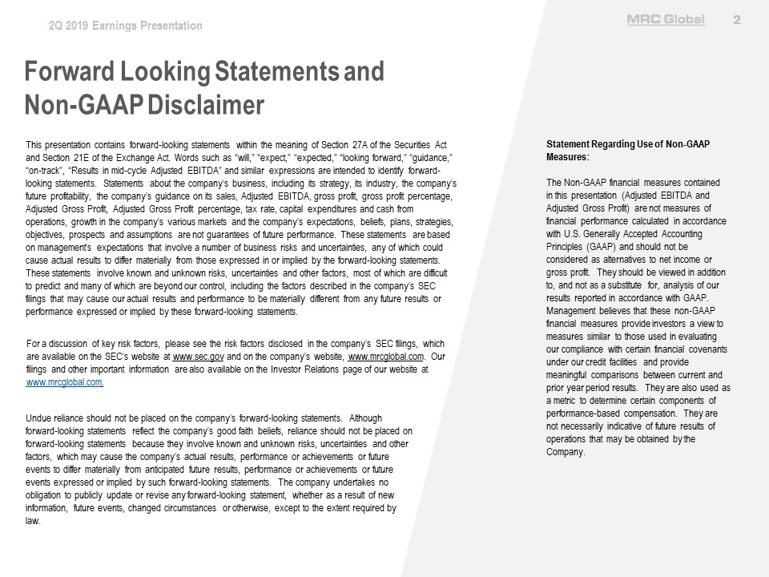
2Q 2019 Earnings Presentation MRC Global 2 Forward Looking Statements and Non-GAAP Disclaimer This presentation contains forward-looking statements within the meaning of Section 27A of the Securities Act and Section 21E of the Exchange Act. Words such as “will,” “expect,” “expected,” “looking forward,” “guidance,” “on-track”, “Results in mid-cycle Adjusted EBITDA” and similar expressions are intended to identify forward-looking statements. Statements about the company’s business, including its strategy, its industry, the company’s future profitability, the company’s guidance on its sales, Adjusted EBITDA, gross profit, gross profit percentage, Adjusted Gross Profit, Adjusted Gross Profit percentage, tax rate, capital expenditures and cash from operations, growth in the company’s various markets and the company’s expectations, beliefs, plans, strategies, objectives, prospects and assumptions are not guarantees of future performance. These statements are based on management’s expectations that involve a number of business risks and uncertainties, any of which could cause actual results to differ materially from those expressed in or implied by the forward-looking statements. These statements involve known and unknown risks, uncertainties and other factors, most of which are difficult to predict and many of which are beyond our control, including the factors described in the company’s SEC filings that may cause our actual results and performance to be materially different from any future results or performance expressed or implied by these forward-looking statements. For a discussion of key risk factors, please see the risk factors disclosed in the company’s SEC filings, which are available on the SEC’s website at www.sec.gov and on the company’s website, www.mrcglobal.com. Our filings and other important information are also available on the Investor Relations page of our website at www.mrcglobal.com. Undue reliance should not be placed on the company’s forward-looking statements. Although forward-looking statements reflect the company’s good faith beliefs, reliance should not be placed on forward-looking statements because they involve known and unknown risks, uncertainties and other factors, which may cause the company’s actual results, performance or achievements or future events to differ materially from anticipated future results, performance or achievements or future events expressed or implied by such forward-looking statements. The company undertakes no obligation to publicly update or revise any forward-looking statement, whether as a result of new information, future events, changed circumstances or otherwise, except to the extent required by law. Statement Regarding Use of Non-GAAP Measures: The Non-GAAP financial measures contained in this presentation (Adjusted EBITDA and Adjusted Gross Profit) are not measures of financial performance calculated in accordance with U.S. Generally Accepted Accounting Principles (GAAP) and should not be considered as alternatives to net income or gross profit. They should be viewed in addition to, and not as a substitute for, analysis of our results reported in accordance with GAAP. Management believes that these non-GAAP financial measures provide investors a view to measures similar to those used in evaluating our compliance with certain financial covenants under our credit facilities and provide meaningful comparisons between current and prior year period results. They are also used as a metric to determine certain components of performance-based compensation. They are not necessarily indicative of future results of operations that may be obtained by the Company. 2

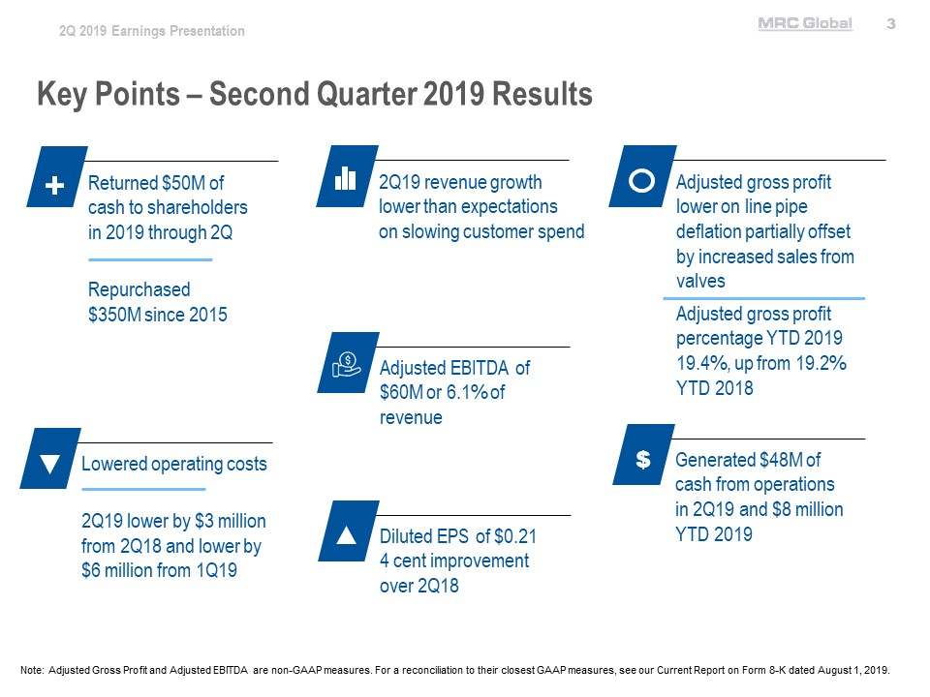
2Q 2019 Earnings Presentation MRC Global 3 Key Points – Second Quarter 2019 Results Returned $50M of cash to shareholders in 2019 through 2Q Repurchased $350M since 2015 2Q19 revenue growth lower than expectations on slowing customer spend Adjusted gross profit lower on line pipe deflation partially offset by increased sales from valves Adjusted gross profit percentage YTD 2019 19.4%, up from 19.2% YTD 2018 Adjusted EBITDA of $60M or 6.1% of revenue Lowered operating costs 2Q19 lower by $3 million from 2Q18 and lower by $6 million from 1Q19 Diluted EPS of $0.21 4 cent improvement over 2Q18 Generated $48M of cash from operations in 2Q19 and $8 million YTD 2019 Note: Adjusted Gross Profit and Adjusted EBITDA are non-GAAP measures. For a reconciliation to their closest GAAP measures, see our Current Report on Form 8-K dated August 1, 2019. 3

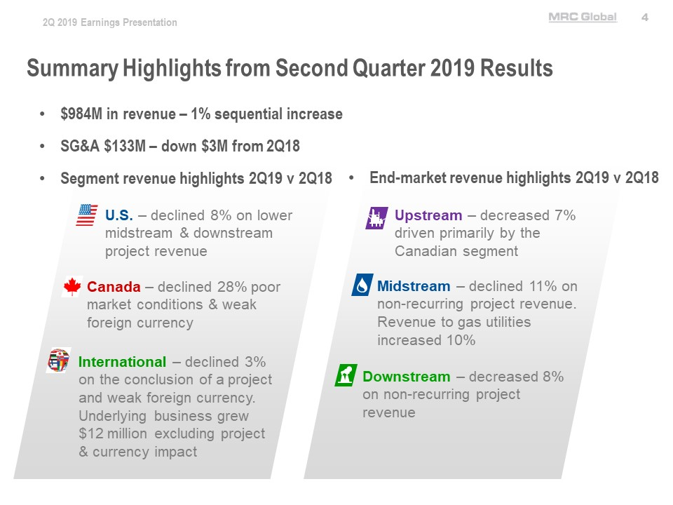
2Q 2019 Earnings Presentation MRC Global 4 Summary Highlights from Second Quarter 2019 Results $984M in revenue – 1% sequential increase SG&A $133M – down $3M from 2Q18 Segment revenue highlights 2Q19 v 2Q18 End-market revenue highlights 2Q19 v 2Q18 U.S. – declined 8% on lower midstream & downstream project revenue Canada – declined 28% poor market conditions & weak foreign currency International – declined 3% on the conclusion of a project and weak foreign currency. Underlying business grew $12 million excluding project & currency impact Upstream – decreased 7% driven primarily by the Canadian segment Midstream – declined 11% on non-recurring project revenue. Revenue to gas utilities increased 10% Downstream – decreased 8% on non-recurring project revenue 4

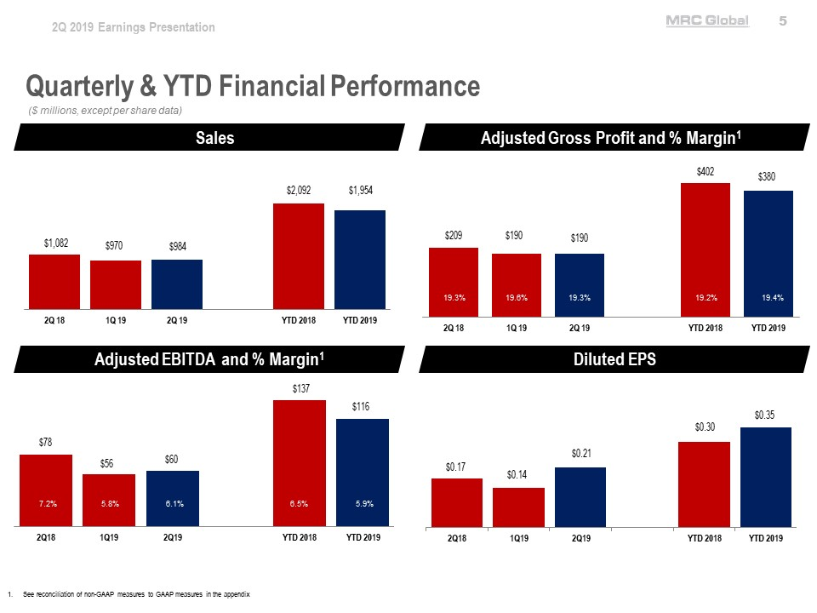
2Q 2019 Earnings Presentation MRC Global 5 Quarterly & YTD Financial Performance ($ millions, except per share data) Sales 2Q18 $1,082 1Q19 $970 2Q19 $984 YTD 2018 $2,092 YTD 2019 $1,954 Adjusted Gross Profit and % Margin1 2Q18 $209 19.3% 1Q19 $190 19.6% 2Q19 $190 19.3% YTD 2018 $402 19.2% YTD 2019 $380 19.4% Adjusted EBITDA and % Margin¹ 2Q18 $78 7.2% 1Q19 $56 5.8% 2Q19 $60 6.1% YTD 2018 $137 6.5% YTD 2019 $116 5.9% Diluted EPS 2Q18 $0.17 1Q19 $0.14 2Q19 $0.21 YTD 2018 $0.30 YTD 2019 $0.35 1. See reconciliation of non-GAAP measures to GAAP measures in the appendix 5

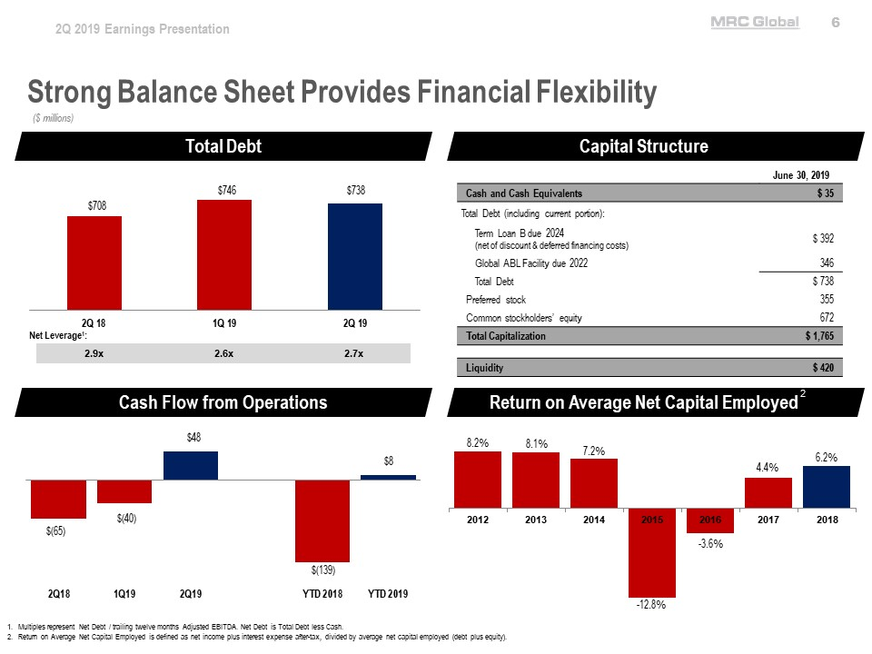
2Q 2019 Earnings Presentation MRC Global 6 Strong Balance Sheet Provides Financial Flexibility ($ millions) Total Debt Net Leverage1: 2.9x 2.6x 2.7x 2Q18 $708 1Q19 $746 2Q19 $738 Capital Structure June 30, 2019 Cash and Cash Equivalents $35 Total Debt (including current portion): Term Loan B due 2024 (net of discount & deferred financing costs) $392 Global ABL Facility due 2022 346 Total Debt $738 Preferred stock 355 Common stockholders’ equity 672 Total Capitalization $1,765 Liquidity $420 Cash Flow from Operations 2Q18 $(65) 1Q19 $(40) 2Q19 $48 YTD 2018 $(139) YTD 2019 $8 Return on Average Net Capital Employed2 2012 8.2% 2013 8.1% 2014 7.2% 2015 -12.8% 2016 -3.6% 2017 4.4% 2018 6.2% 1. Multiples represent Net Debt / trailing twelve months Adjusted EBITDA. Net Debt is Total Debt less Cash. 2. Return on Average Net Capital Employed is defined as net income plus interest expense after-tax, divided by average net capital employed (debt plus equity). 6

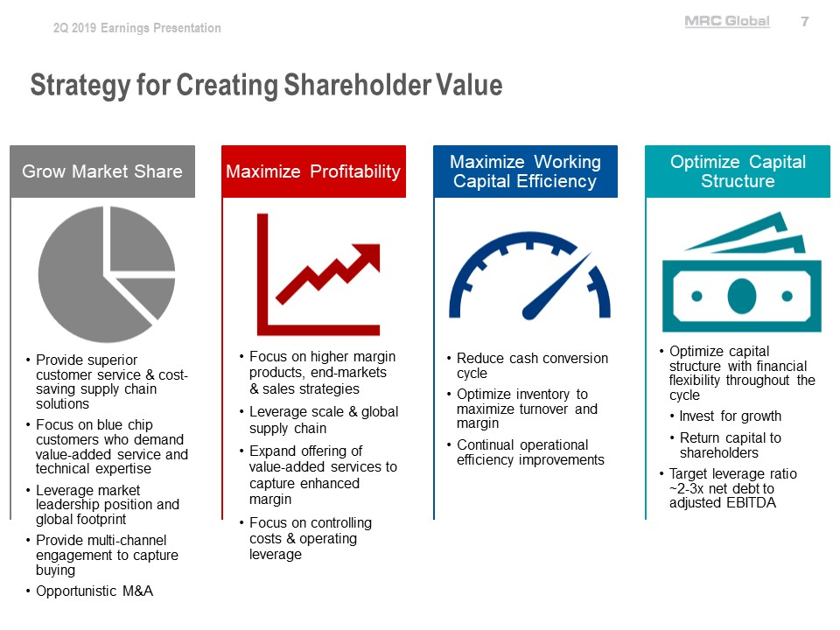
2Q 2019 Earnings Presentation MRC Global 7 Strategy for Creating Shareholder Value Grow Market Share Provide superior customer service & cost-saving supply chain solutions Focus on blue chip customers who demand value-added service and technical expertise Leverage market leadership position and global footprint Provide multi-channel engagement to capture buying Opportunistic M&A Maximize Profitability Focus on higher margin products, end-markets & sales strategies Leverage scale & global supply chain Expand offering of value-added services to capture enhanced margin Focus on controlling costs & operating leverage Maximize Working Capital Efficiency Reduce cash conversion cycle Optimize inventory to maximize turnover and margin Continual operational efficiency improvements Optimize Capital Structure Optimize capital structure with financial flexibility throughout the cycle Invest for growth Return capital to shareholders Target leverage ratio ~2-3x net debt to adjusted EBITDA 7
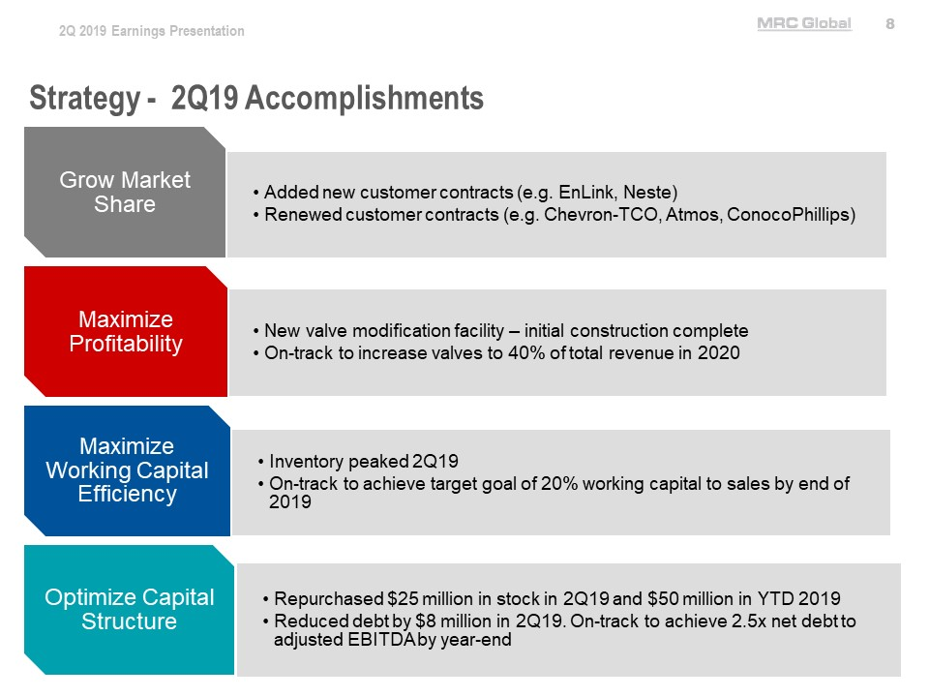
2Q 2019 Earnings Presentation MRC Global 8 Strategy - 2Q19 Accomplishments Grow Market Share Added new customer contracts (e.g. EnLink, Neste) Renewed customer contracts (e.g. Chevron-TCO, Atmos, ConocoPhillips) Maximize Profitability New valve modification facility – initial construction complete On-track to increase valves to 40% of total revenue in 2020 Maximize Working Capital Efficiency Inventory peaked 2Q19 On-track to achieve target goal of 20% working capital to sales by end of 2019 Optimize Capital Structure Repurchased $25 million in stock in 2Q19 and $50 million in YTD 2019 Reduced debt by $8 million in 2Q19. On-track to achieve 2.5x net debt to adjusted EBITDA by year-end 8

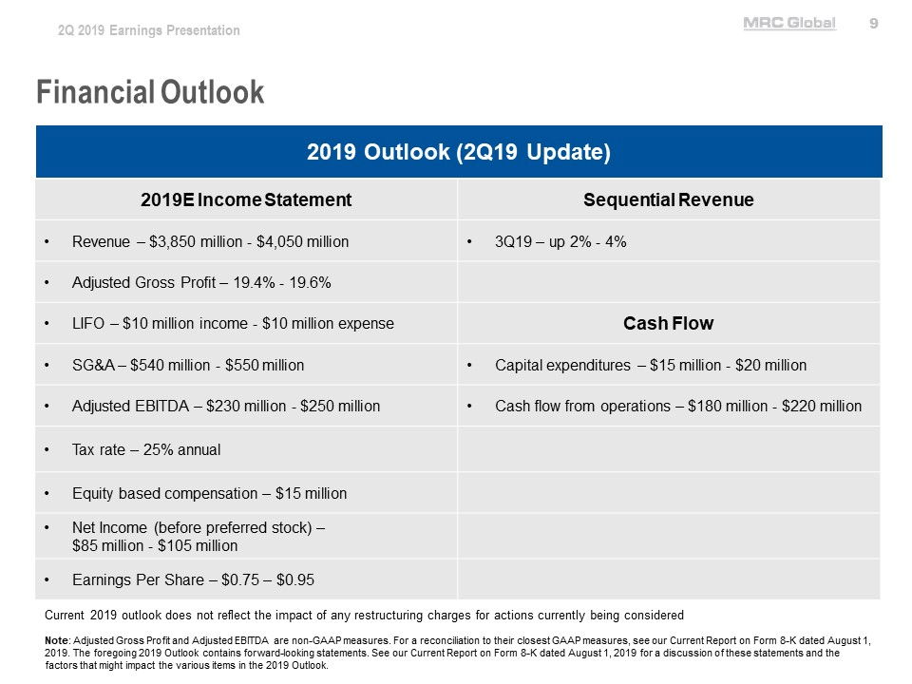
2Q 2019 Earnings Presentation MRC Global 9 Financial Outlook 2019 Outlook (2Q19 Update) 2019E Income Statement Revenue – $3,850 million - $4,050 million Adjusted Gross Profit – 19.4% - 19.6% LIFO – $10 million income - $10 million expense SG&A – $540 million - $550 million Adjusted EBITDA – $230 million - $250 million Tax rate – 25% annual Equity based compensation – $15 million Net Income (before preferred stock) – $85 million - $105 million Earnings Per Share – $0.75 – $0.95 Sequential Revenue 3Q19 – up 2% - 4% Cash Flow Capital expenditures – $15 million - $20 million Cash flow from operations – $180 million - $220 million Current 2019 outlook does not reflect the impact of any restructuring charges for actions currently being considered Note: Adjusted Gross Profit and Adjusted EBITDA are non-GAAP measures. For a reconciliation to their closest GAAP measures, see our Current Report on Form 8-K dated August 1, 2019. The foregoing 2019 Outlook contains forward-looking statements. See our Current Report on Form 8-K dated August 1, 2019 for a discussion of these statements and the factors that might impact the various items in the 2019 Outlook. 9

a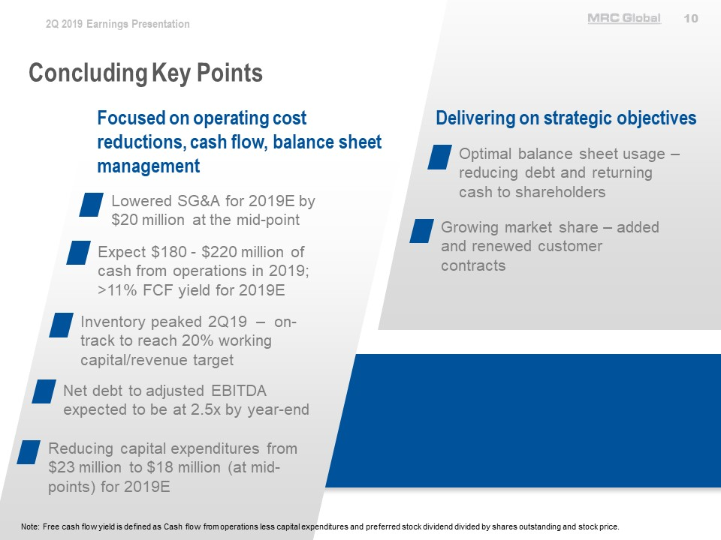
2Q 2019 Earnings Presentation MRC Global 10 Concluding Key Points Focused on operating cost reductions, cash flow, balance sheet management Lowered SG&A for 2019E by $20 million at the mid-point Expect $180 - $220 million of cash from operations in 2019; >11% FCF yield for 2019E Inventory peaked 2Q19 – on-track to reach 20% working capital/revenue target Net debt to adjusted EBITDA expected to be at 2.5x by year-end Reducing capital expenditures from $23 million to $18 million (at mid-points) for 2019E Delivering on strategic objectives Optimal balance sheet usage – reducing debt and returning cash to shareholders Growing market share – added and renewed customer contracts Note: Free cash flow yield is defined as Cash flow from operations less capital expenditures and preferred stock dividend divided by shares outstanding and stock price. 10

2Q 2019 Earnings Presentation MRC Global 11 Appendix 11

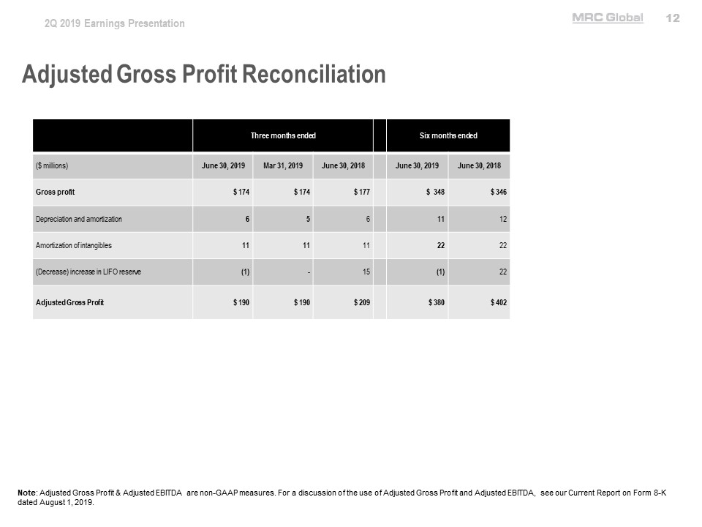
2Q 2019 Earnings Presentation MRC Global 12 Adjusted Gross Profit Reconciliation Three months Six months ended ($ millions) June 30, 2019 Mar 31, 2019 June 30, 2018 June 30, 2019 June 30, 2018 Gross profit $174 $174 $177 $348 $346 Depreciation and amortization 6 5 6 11 12 Amortization of intangibles 11 11 11 22 22 (Decrease) increase in LIFO reserve (1) – 15 (1) 22 Adjusted Gross Profit $190 $190 $209 $380 $402 Note: Adjusted Gross Profit & Adjusted EBITDA are non-GAAP measures. For a discussion of the use of Adjusted Gross Profit and Adjusted EBITDA, see our Current Report on Form 8-K dated August 1, 2019. 12

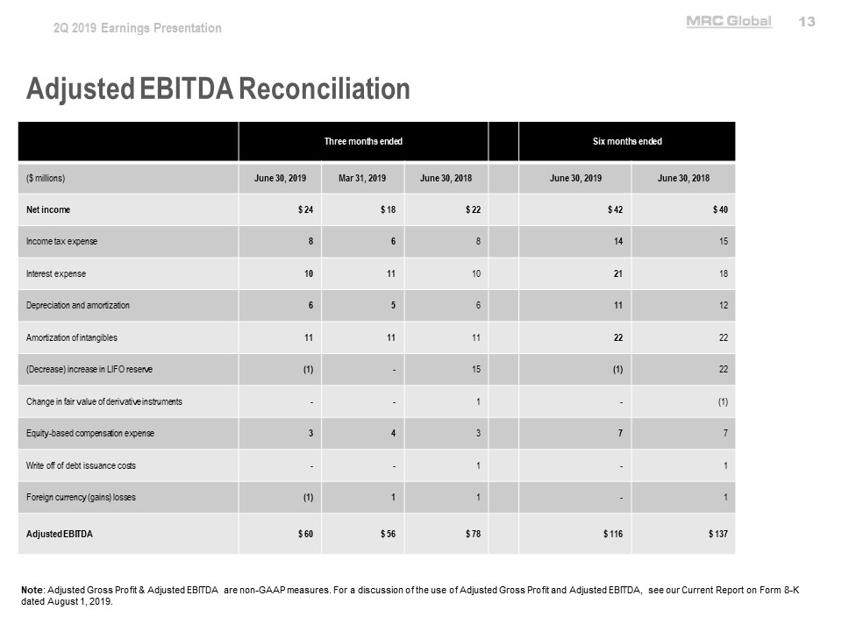
2Q 2019 Earnings Presentation MRC Global 13 Adjusted EBITDA Reconciliation Three months ended Six months ended ($ millions) June 30, 2019 Mar 31, 2019 June 30, 2018 June 30, 2019 June 30, 2018 Net income $24 $18 $22 $42 $40 Income tax expense 8 6 8 14 15 Interest expense 10 11 10 21 18 Depreciation and amortization 6 5 6 11 12 Amortization of intangibles 11 11 11 22 22 (Decrease) increase in LIFO reserve (1) – 15 (1) 22 Change in fair value of derivative instruments - - 1 – (1) Equity-based compensation expense 3 4 3 7 7 Write off of debt issuance costs - - 1 – 1 Foreign currency (gains) losses (1) 1 1 – 1 Adjusted EBITDA $60 $56 $78 $116 $137 Note: Adjusted Gross Profit & Adjusted EBITDA are non-GAAP measures. For a discussion of the use of Adjusted Gross Profit and Adjusted EBITDA, see our Current Report on Form 8-K dated August 1, 2019. 13

